Economics - Canadian Edition, 15e (Ragan)
Chapter 14 Labour Markets and Income Inequality

14.1 Wage Differentials

1) In a perfectly competitive labour market, all workers would earn the same wage if
A) the world was fair.
B) workers' education and experience were identical.
C) all jobs had the same working conditions.
D) regional variables mattered.
E) jobs and workers were identical in every way.
Answer: E
Diff: 1
Topic: 14.1a. wage differentials in competitive markets
Skill: Recall
Learning Obj.: 14-1 Explain wage differentials in both competitive and non-competitive labour markets.
User2: Qualitative

2) If labour markets were perfectly competitive,
A) all workers would eventually earn the same wage.
B) all workers would achieve the same levels of education and experience.
C) working conditions would be the same for all jobs.
D) wage differentials could still exist because of differences in workers and jobs.
E) discrimination could not create wage differentials.
Answer: D
Diff: 1
Topic: 14.1a. wage differentials in competitive markets
Skill: Applied
Learning Obj.: 14-1 Explain wage differentials in both competitive and non-competitive labour markets.
User2: Qualitative

3) One possible reason for wage differentials is that
A) there are competitive forces operating in labour markets.
B) discrimination affects labour-market outcomes.
C) working conditions are the same for most jobs.
D) workers have more-or-less equal skills.
E) there is only a single national labour market.
Answer: B
Diff: 1
Topic: 14.1a. wage differentials in competitive markets
Skill: Recall
Learning Obj.: 14-1 Explain wage differentials in both competitive and non-competitive labour markets.
User2: Qualitative
4) Other things being equal, individuals working in relatively risky working conditions generally
A) earn higher wages due to the greater relative demand for these individuals.
B) earn higher wages due to the reduced supply of risk-taking individuals.
C) earn lower wages because of the scarcity of these jobs.
D) do not concern economists as these situations are uncommon.
E) work in perfectly competitive labour markets.
Answer: B
Diff: 1
Topic: 14.1a. wage differentials in competitive markets
Skill: Recall
Learning Obj.: 14-1 Explain wage differentials in both competitive and non-competitive labour markets.
User2: Qualitative

5) All of the following are classified as human capital EXCEPT
A) education.
B) training.
C) gender.
D) health.
E) experience.
Answer: C
Diff: 1
Topic: 14.1a. wage differentials in competitive markets
Skill: Applied
Learning Obj.: 14-1 Explain wage differentials in both competitive and non-competitive labour markets.
User2: Qualitative

6) One attempt to provide some minimum level of human capital for all citizens is a system of
A) compulsory and publicly financed education.
B) income taxation.
C) unionism.
D) comparable worth.
E) minimum wages.
Answer: A
Diff: 1
Topic: 14.1a. wage differentials in competitive markets
Skill: Recall
Learning Obj.: 14-1 Explain wage differentials in both competitive and non-competitive labour markets.
User2: Qualitative

7) If you choose to stay in school beyond the compulsory minimum period, you are
A) realizing the benefits of your investment in human capital.
B) delaying your investment in human capital.
C) refusing to invest in your human capital.
D) investing further in your human capital.
E) wasting your time from an economic standpoint.
Answer: D
Diff: 1
Topic: 14.1a. wage differentials in competitive markets
Skill: Applied
Learning Obj.: 14-1 Explain wage differentials in both competitive and non-competitive labour markets.
User2: Qualitative
8) During recessions, individual investment in higher education typically ________ due to the relatively ________ opportunity cost of time spent in university.
A) rises; high
B) rises; low
C) falls; high
D) falls; low
E) stays constant; constant
Answer: B
Diff: 2
Topic: 14.1a. wage differentials in competitive markets
Skill: Applied
Learning Obj.: 14-1 Explain wage differentials in both competitive and non-competitive labour markets.
User2: Qualitative

9) Investment in human capital can be very costly to the individual, but it can also generate large returns. Canadian census data from 2007 show that average employment income for a university graduate is approximately ________ of the average employment income of a worker with no more than a high school diploma.
A) 50%
B) 125%
C) 200%
D) 300%
E) 400%
Answer: C
Diff: 2
Topic: 14.1a. wage differentials in competitive markets
Skill: Recall
Learning Obj.: 14-1 Explain wage differentials in both competitive and non-competitive labour markets.
User2: Qualitative

10) Wage differentials due to cross-worker differences in human capital
A) are not justifiable on efficiency grounds.
B) will persist in competitive equilibrium.
C) are not an important source of observed wage differentials.
D) are an example of economic distortions due to monopoly power.
E) exist because of distortions in labour markets.
Answer: B
Diff: 2
Topic: 14.1a. wage differentials in competitive markets
Skill: Recall
Learning Obj.: 14-1 Explain wage differentials in both competitive and non-competitive labour markets.
User2: Qualitative
11) A typical firm hiring in a perfectly competitive labour market faces a marginal cost curve for labour that is
A) horizontal.
B) vertical.
C) equal to the supply curve of the firm.
D) parallel to the firm's marginal cost curve for its product.
E) downward sloping.
Answer: A
Diff: 2
Topic: 14.1a. wage differentials in competitive markets
Skill: Applied
Learning Obj.: 14-1 Explain wage differentials in both competitive and non-competitive labour markets.
User2: Qualitative

12) In terms of human capital, which of the following is the best example of an inherited skill?
A) a neurosurgeon who can perform brain surgery after many years of training
B) a retail worker who is able to work overtime each week
C) a worker who exercises is healthier and therefore more productive
D) a salesman doubles his sales after taking a training course
E) a music teacher who can carry a tune for the school choir
Answer: E
Diff: 1
Topic: 14.1a. wage differentials in competitive markets
Skill: Applied
Learning Obj.: 14-1 Explain wage differentials in both competitive and non-competitive labour markets.
User2: Qualitative

13) One or two generations ago, fewer Canadians completed post-secondary training and education. One explanation for this is
A) a decrease in demand for more education in recent years.
B) wage differentials due to formal education have diminished over time.
C) a negative relationship between the acquisition of human capital and overall earnings.
D) the relative wage of more highly educated people has increased in recent years.
E) that the opportunity cost of post-secondary education has increased.
Answer: D
Diff: 2
Topic: 14.1a. wage differentials in competitive markets
Skill: Applied
Learning Obj.: 14-1 Explain wage differentials in both competitive and non-competitive labour markets.
User2: Qualitative
14) In recent years, some business schools in Canada have begun charging tuition of close to $35 000 per year for a graduate degree, whereas Arts faculties charge much lower tuition for their graduate degrees. Students are prepared to pay the high tuition in a business school because
A) the expected payoff in terms of higher future wages is large.
B) the cost of providing the business education is far higher than the cost of the Arts education.
C) the marginal revenue product of a business degree is lower than the marginal revenue product of an Arts degree.
D) the marginal cost of a business degree is less than the marginal benefit of a business degree.
E) they recognize that the investment in human capital is not worthwhile.
Answer: A
Diff: 2
Topic: 14.1a. wage differentials in competitive markets
Skill: Applied
Learning Obj.: 14-1 Explain wage differentials in both competitive and non-competitive labour markets.
User2: Qualitative

The table below shows the labour demand and labour supply schedules in a competitive labour market.

Wage Rate  ($/hour) | Quantity Demanded  of Labour  (hours/month) | Quantity Supplied  of Labour (hours/month)
10 | 1300 | 500
12 | 1000 | 1000
14 | 800 | 1300
15 | 400 | 1500
17 | 200 | 1800

TABLE 14-1

15) Refer to Table 14-1. In a competitive labour market that clears, the equilibrium employment level would be
A) 400 units.
B) 500 units.
C) 800 units.
D) 1000 units.
E) 1300 units.
Answer: D
Diff: 1
Topic: 14.1a. wage differentials in competitive markets
Skill: Applied
Learning Obj.: 14-1 Explain wage differentials in both competitive and non-competitive labour markets.
User1: Table
User2: Quantitative
16) Refer to Table 14-1. If the wage rate is $15 per hour, how many hours per month are supplied to this market but are not actually employed?
A) 0
B) 400
C) 1000
D) 1100
E) 1500
Answer: D
Diff: 2
Topic: 14.1a. wage differentials in competitive markets
Skill: Applied
Learning Obj.: 14-1 Explain wage differentials in both competitive and non-competitive labour markets.
User1: Table
User2: Quantitative

17) Refer to Table 14-1. In this labour market, if the wage rate is $10 per hour, how many hours of labour per month are actually employed?
A) 0
B) 500
C) 1000
D) 1300
E) 1850
Answer: B
Diff: 2
Topic: 14.1a. wage differentials in competitive markets
Skill: Applied
Learning Obj.: 14-1 Explain wage differentials in both competitive and non-competitive labour markets.
User1: Table
User2: Quantitative

18) Labour-market discrimination results in a
A) lower supply in discriminating occupations and a higher supply in non-discriminating occupations.
B) higher supply in discriminating occupations and a lower supply in non-discriminating occupations.
C) lower supply in all occupations.
D) lower demand in all occupations.
E) higher demand in both occupations.
Answer: A
Diff: 2
Topic: 14.1b. discrimination
Skill: Recall
Learning Obj.: 14-1 Explain wage differentials in both competitive and non-competitive labour markets.
User2: Qualitative
19) Labour-market discrimination, which keeps one group of workers out of elite (E) occupations and limits them to ordinary (O) occupations, will have which of the following effects?
A) a decrease in supply and higher wages in the E occupations
B) more employment in the E occupations
C) a decrease in supply and lower wages in the O occupations
D) more unemployment in the E occupations
E) a decrease in supply and higher wages in the O occupation
Answer: A
Diff: 2
Topic: 14.1b. discrimination
Skill: Applied
Learning Obj.: 14-1 Explain wage differentials in both competitive and non-competitive labour markets.
User2: Qualitative

20) Labour-market discrimination, which keeps one group of workers out of elite (E) occupations and limits them to ordinary (O) occupations, will have which of the following effects?
A) a decrease in supply and lower wages in the O occupations
B) an increase in supply and lower wages in the E occupations
C) an increase in supply and higher wages in the E occupations
D) a decrease in supply and lower wages in the E occupations
E) an increase in supply and lower wages in the O occupations
Answer: E
Diff: 2
Topic: 14.1b. discrimination
Skill: Applied
Learning Obj.: 14-1 Explain wage differentials in both competitive and non-competitive labour markets.
User2: Qualitative

21) If competitive labour market E discriminates against one group of workers and market O does not, we can predict an increase in
A) employment in market E.
B) wages in market E.
C) wages in market O.
D) the welfare of the average worker.
E) economy-wide wage rates.
Answer: B
Diff: 1
Topic: 14.1b. discrimination
Skill: Applied
Learning Obj.: 14-1 Explain wage differentials in both competitive and non-competitive labour markets.
User2: Qualitative
22) Suppose market E discriminates against one group of workers and market O does not. Unemployment in market O would result if
A) the free-market equilibrium wage in market O is below the legal minimum wage.
B) some workers are unwilling to work in E-market jobs.
C) there is no statutory minimum wage.
D) the supply curve in market O shifts to the left and wages are slow to adjust.
E) the demand curve in market O shifts to the right and wages are slow to adjust.
Answer: A
Diff: 3
Topic: 14.1b. discrimination
Skill: Applied
Learning Obj.: 14-1 Explain wage differentials in both competitive and non-competitive labour markets.
User2: Qualitative

23) Evidence suggests that some of the observed average female-male wage differential can be explained by
A) the nature of the jobs and differences in acquired human capital.
B) differences in the innate abilities between men and women.
C) higher marginal revenue product for female workers.
D) the labour-force participation rate of adult women being above that of adult men.
E) None of the above can explain part of the wage differentials.
Answer: A
Diff: 2
Topic: 14.1b. discrimination
Skill: Applied
Learning Obj.: 14-1 Explain wage differentials in both competitive and non-competitive labour markets.
User2: Qualitative

24) Some types of discrimination in the labour market will be limited by
A) the minimum wage.
B) entry of of discriminating firms into the market.
C) an increase in the number of individuals discriminated against.
D) the desire of firms to maximize profits.
E) greater monopoly power in the market.
Answer: D
Diff: 2
Topic: 14.1b. discrimination
Skill: Applied
Learning Obj.: 14-1 Explain wage differentials in both competitive and non-competitive labour markets.
User2: Qualitative
25) The following statements describe the adverse effects suffered by groups subject to labour-market discrimination. Which of the statements is false?
A) They will be more likely to experience spells of unemployment.
B) Their children's ability and willingness to invest in human capital will be less on average than those of children of other groups.
C) They will receive lower wages on average than other groups.
D) Their human capital will increase.
E) The discriminatory wage differentials will persist as long as the discrimination exists.
Answer: D
Diff: 1
Topic: 14.1b. discrimination
Skill: Recall
Learning Obj.: 14-1 Explain wage differentials in both competitive and non-competitive labour markets.
User2: Qualitative

26) If there is discrimination against some workers in market A but no discrimination in market B, then we can predict
1) a decrease in supply and higher wages in the A occupations.;
2) more employment in the A occupations.;
3) more unemployment in the B occupations if there is a binding minimum wage.
A) 1 only
B) 2 only
C) 3 only
D) 1 and 2
E) 1 and 3
Answer: E
Diff: 3
Topic: 14.1b. discrimination
Skill: Applied
Learning Obj.: 14-1 Explain wage differentials in both competitive and non-competitive labour markets.
User2: Qualitative
Suppose an island economy has only two labour markets - fishing (high skill) and farming (low skill). There are 1000 males and 1000 females in the labour force. There is an equal distribution of skilled and non-skilled workers among each sex.

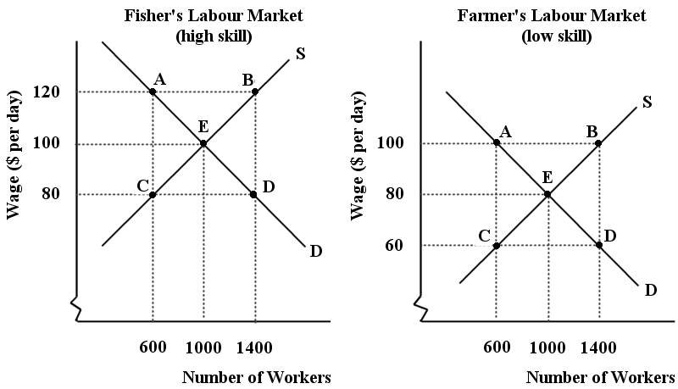

FIGURE 14-1

27) Refer to Figure 14-1. The two labour markets are each in a ________ equilibrium at point E. The wage differential between the industries is a(n) ________ wage differential.
A) non-competitive; discriminatory
B) competitive; temporary
C) competitive; equilibrium
D) non-competitive; temporary
E) competitive; discriminatory
Answer: C
Diff: 2
Topic: 14.1b. discrimination
Skill: Applied
Learning Obj.: 14-1 Explain wage differentials in both competitive and non-competitive labour markets.
User1: Graph
User2: Qualitative
28) Refer to Figure 14-1. Suppose the employers in the fishers labour market begin to discriminate against male workers. Which of the following can we expect to occur in the fishers labour market?
A) There will be an equal flow of workers between the two markets, equilibrium will remain at point E and the wage at $100 per day.
B) The demand for labour curve shifts to the right until a new equilibrium is reached at point B and the wage rises to $120 per day.
C) The labour supply curve shifts to the left until a new equilibrium is reached at point A and the wage rises to $120 per day.
D) The demand for labour curve shifts to the left until a new equilibrium is reached at point C and the wage falls to $80 per day.
E) The labour supply curve shifts to the right until a new equilibrium is reached at point D and the wage falls to $80 per day.
Answer: C
Diff: 2
Topic: 14.1b. discrimination
Skill: Applied
Learning Obj.: 14-1 Explain wage differentials in both competitive and non-competitive labour markets.
User1: Graph
User2: Quantitative

29) Refer to Figure 14-1. Suppose the employers in the fishers labour market begin to discriminate against male workers. Which of the following can we expect to occur in the farmers labour market?
A) There will be an equal flow of workers between the two markets, equilibrium will remain at point E and the wage at $80 per day.
B) The demand for labour curve shifts to the right until a new equilibrium is reached at point B and the wage rises to $100 per day.
C) The labour supply curve shifts to the left until a new equilibrium is reached at point A and the wage rises to $100 per day.
D) The demand for labour curve shifts to the left until a new equilibrium is reached at point C and the wage falls to $60 per day.
E) The labour supply curve shifts to the right until a new equilibrium is reached at point D and the wage falls to $60 per day.
Answer: E
Diff: 2
Topic: 14.1b. discrimination
Skill: Applied
Learning Obj.: 14-1 Explain wage differentials in both competitive and non-competitive labour markets.
User1: Graph
User2: Quantitative
30) Refer to Figure 14-1. Suppose the employers in the fishers labour market begin to discriminate against male workers, and we move to a new equilibrium in each market. In the absence of any government intervention in these markets, what forces might we expect to see over time?
1) All female workers will migrate to the fishers labour market due to the higher wage.
2) The discriminatory wage differential will tend to be eliminated by the pursuit of profit.
3) Some firm owners in the fishing labour market will find it profitable to hire high-skill males, thus reducing the wage differential.
A) 1 only
B) 2 only
C) 3 only
D) 1 and 2
E) 2 and 3
Answer: E
Diff: 3
Topic: 14.1b. discrimination
Skill: Applied
Learning Obj.: 14-1 Explain wage differentials in both competitive and non-competitive labour markets.
User1: Graph
User2: Qualitative

31) Certain professions limit the number of students who are eligible to enroll in their programs in university - engineering, architecture, dentistry, and law, for example. Other things being equal, what is one predicted effect of such restrictions?
A) increased wages across all segments of the labour market
B) decreased wages across all segments of the labour market
C) decreased wages in the labour market outside of these professions
D) increased wages in the labour market outside of these professions
E) there will be no effect on any wages
Answer: C
Diff: 2
Topic: 14.1a. wage differentials in competitive markets
Skill: Applied
Learning Obj.: 14-1 Explain wage differentials in both competitive and non-competitive labour markets.
User2: Qualitative

32) If there is only a single buyer in the labour market, that buyer is called
A) a monopolist.
B) a monopsonist.
C) an oligopolist.
D) an oligopsonist.
E) a single-product firm.
Answer: B
Diff: 1
Topic: 14.1c. wage differentials in non-competitive markets
Skill: Recall
Learning Obj.: 14-2 Describe the possible effects of legislated minimum wages.
User2: Qualitative
33) As a seller of labour services, a labour union is a form of
A) monopoly.
B) monopsony.
C) oligopoly.
D) monopolistic competitor.
E) illegal cartel.
Answer: A
Diff: 1
Topic: 14.1c. wage differentials in non-competitive markets
Skill: Recall
Learning Obj.: 14-2 Describe the possible effects of legislated minimum wages.
User2: Qualitative

34) A labour union can most easily raise the wages received by its members by
A) increasing the demand for the product.
B) decreasing the supply of labour from its members.
C) raising employment.
D) increasing the demand for labour.
E) improving productivity.
Answer: B
Diff: 1
Topic: 14.1c. wage differentials in non-competitive markets
Skill: Recall
Learning Obj.: 14-2 Describe the possible effects of legislated minimum wages.
User2: Qualitative

35) In the 1950s and 1960s, Arvida, Quebec, was basically a one-company town where Alcan was the sole buyer of labour services. This is a good example of
A) pure monopoly.
B) monopolistic competition.
C) oligopoly.
D) monopsony.
E) union power.
Answer: D
Diff: 1
Topic: 14.1c. wage differentials in non-competitive markets
Skill: Applied
Learning Obj.: 14-2 Describe the possible effects of legislated minimum wages.
User2: Qualitative
36) Suppose a labour union enters a competitive labour market and is successful in raising wages above the competitive equilibrium level. In this situation,
A) each firm in the industry will face a horizontal supply curve for labour at the union wage, up to the maximum quantity of labour that is prepared to work at that wage.
B) those workers already employed will earn a lower wage than before.
C) employment in the industry will surely increase.
D) the market supply curve for labour will be upward sloping over its entire range.
E) the number of firms in the industry will increase and the demand for labour curve will shift to the right, causing a subsequent increase in the wage.
Answer: A
Diff: 3
Topic: 14.1c. wage differentials in non-competitive markets
Skill: Applied
Learning Obj.: 14-2 Describe the possible effects of legislated minimum wages.
User2: Qualitative

37) Suppose that a professional association strengthened the limits to entry into their profession and at the same time lengthened its required apprenticeship program. The likely effect would be that
A) the supply curve for labour would shift to the left.
B) the supply curve for labour would shift to the right.
C) both the demand and supply curves for labour would shift to the left.
D) the demand curve for labour would shift to the right.
E) there would be an increase in the quantity of labour supplied.
Answer: A
Diff: 1
Topic: 14.1c. wage differentials in non-competitive markets
Skill: Applied
Learning Obj.: 14-2 Describe the possible effects of legislated minimum wages.
User2: Qualitative

38) Certain professions limit the number of students who are eligible to enroll in their programs in university - engineering, architecture, dentistry, and law, for example. What is the predicted effect of such a policy in each of these professions?
A) An increase in supply and a wage that is lower than it otherwise would be.
B) A reduction in supply and a wage that is lower than it otherwise would be.
C) An increase in supply and a wage that is higher than it otherwise would be.
D) A reduction in supply and a wage that is higher than it otherwise would be.
E) These professions are a relatively small portion of the labour market and so there will be no detectible change in wages.
Answer: D
Diff: 2
Topic: 14.1c. wage differentials in non-competitive markets
Skill: Applied
Learning Obj.: 14-2 Describe the possible effects of legislated minimum wages.
User2: Qualitative
39) To a monopsonist in a labour market, the average cost curve of labour
A) lies above the supply curve of labour.
B) lies below the supply curve of labour.
C) is the supply curve of labour, which lies below the marginal cost curve for labour.
D) is the marginal cost curve of labour when the supply curve is upward sloping.
E) coincides with the marginal cost curve of labour only below the profit-maximizing wage rate.
Answer: C
Diff: 3
Topic: 14.1c. wage differentials in non-competitive markets
Skill: Recall
Learning Obj.: 14-2 Describe the possible effects of legislated minimum wages.
User2: Qualitative

40) For a monopsonist in a labour market, the firm's MC curve for labour lies ________ the competitive supply curve for labour; just as the marginal revenue curve for a monopolist lies ________ the demand curve for its product.
A) below; below
B) below; above
C) above; above
D) above; below
Answer: D
Diff: 2
Topic: 14.1c. wage differentials in non-competitive markets
Skill: Recall
Learning Obj.: 14-2 Describe the possible effects of legislated minimum wages.
User2: Qualitative

41) For a monopsonist that faces an upward-sloping labour supply curve, the marginal cost of labour curve will be ________ the supply curve because ________.
A) below; the increased wage necessary to attract an extra worker is paid to that worker alone
B) above; the increased wage necessary to attract an extra worker must be paid to everyone already employed
C) above; the average wage exceeds the marginal wage when the average wage is rising
D) the same as; the marginal cost of labour equals the average cost of labour
E) below; the extra labour supplied is less capable than previous units of labour supplied
Answer: B
Diff: 3
Topic: 14.1c. wage differentials in non-competitive markets
Skill: Applied
Learning Obj.: 14-2 Describe the possible effects of legislated minimum wages.
User2: Qualitative
42) A profit-maximizing monopsonist in a labour market will continue to hire labour until the
A) hourly wage of the labour is equated with its marginal cost.
B) hourly wage of the labour is equated with its average cost.
C) marginal revenue product of labour equals its marginal cost.
D) marginal cost of labour equals its average revenue.
E) marginal product of labour is maximized.
Answer: C
Diff: 2
Topic: 14.1c. wage differentials in non-competitive markets
Skill: Applied
Learning Obj.: 14-2 Describe the possible effects of legislated minimum wages.
User2: Qualitative

43) Suppose your firm is a monopsonist hiring only one variable input. If you want to maximize profits, you will purchase that variable input up to the point where the
A) demand curve intersects the supply curve of the input.
B) MRP curve for the input intersects the marginal cost curve for the input.
C) wage rate is the highest.
D) marginal product of that input equals the price of one unit of the input.
E) cost of the input equals the profit generated by the employment of that input.
Answer: B
Diff: 2
Topic: 14.1c. wage differentials in non-competitive markets
Skill: Applied
Learning Obj.: 14-2 Describe the possible effects of legislated minimum wages.
User2: Qualitative

44) If we compare the wage rate and the level of employment achieved in a competitive labour market with those in a monopsonistic labour market, the latter will generate
A) a lower level of employment and a higher wage rate.
B) a higher level of employment and a lower wage.
C) a higher level of employment and a higher wage rate.
D) a lower level of employment and a lower wage.
E) the same outcomes as in a competitive labour market.
Answer: D
Diff: 2
Topic: 14.1c. wage differentials in non-competitive markets
Skill: Applied
Learning Obj.: 14-2 Describe the possible effects of legislated minimum wages.
User2: Qualitative
45) Consider a monopsonistic labour market. Ten units of labour will be supplied if the wage rate is $12, and 11 units of labour will be supplied if the wage rate is $14. The marginal cost of the eleventh worker is
A) $2.
B) $12.
C) between $12 and $14.
D) $14.
E) more than $14.
Answer: E
Diff: 3
Topic: 14.1c. wage differentials in non-competitive markets
Skill: Applied
Learning Obj.: 14-2 Describe the possible effects of legislated minimum wages.
User2: Quantitative

46) Consider a monopsonistic labour market. One hundred units of labour will be supplied if the wage rate is $12, and 101 units of labour will be supplied if the wage rate is $14. The marginal cost of the 101st worker is
A) $14.
B) $140.
C) $214.
D) $1414.
E) Not enough information to know.
Answer: C
Diff: 3
Topic: 14.1c. wage differentials in non-competitive markets
Skill: Applied
Learning Obj.: 14-2 Describe the possible effects of legislated minimum wages.
User2: Quantitative

47) Consider a small, remote town with only one employer - a gold mining company. Suppose the current work force is 875 workers, each of whom is paid $6000 per month. In order to attract one additional worker, the employer must increase the wage to $6025 per month. The marginal cost of this additional worker is
A) $21 875 per month.
B) $21 900 per month.
C) $27 900 per month.
D) $5.25 million per month.
E) $5.28 million per month.
Answer: C
Diff: 3
Topic: 14.1c. wage differentials in non-competitive markets
Skill: Applied
Learning Obj.: 14-2 Describe the possible effects of legislated minimum wages.
User2: Quantitative
48) Suppose that a regional health authority is the only employer of nurses, and further, suppose that nurses are not unionized. The 625 currently employed nurses are paid $27 per hour. To attract an additional nurse, the employer must increase the wage to $28 per hour. The marginal cost of this additional worker is
A) $653.
B) $28.
C) $17 500.
D) $17 528.
E) $27.
Answer: A
Diff: 3
Topic: 14.1c. wage differentials in non-competitive markets
Skill: Applied
Learning Obj.: 14-2 Describe the possible effects of legislated minimum wages.
User2: Quantitative

49) Suppose we have a labour market with a monopsony employer in a town. Now suppose that all workers form a union and negotiate a wage with the employer. We refer to this as a situation of
A) double monopsony.
B) collective bargaining.
C) union-wage premium.
D) bilateral monopoly.
E) monopsony.
Answer: D
Diff: 2
Topic: 14.1c. wage differentials in non-competitive markets
Skill: Applied
Learning Obj.: 14-2 Describe the possible effects of legislated minimum wages.
User2: Qualitative

50) Consider a wage-setting union in an otherwise competitive labour market. If the union sets a wage above the competitive level, the effect will be
A) to raise wages for all workers who wish to work in the industry.
B) to increase the amount of employment in the industry.
C) to create a group of workers who would like to obtain jobs in the industry but cannot do so.
D) a level of employment which is the same as that at the competitive equilibrium wage.
E) to cause the labour supply curve to shift to the right.
Answer: C
Diff: 2
Topic: 14.1c. wage differentials in non-competitive markets
Skill: Applied
Learning Obj.: 14-2 Describe the possible effects of legislated minimum wages.
User2: Qualitative
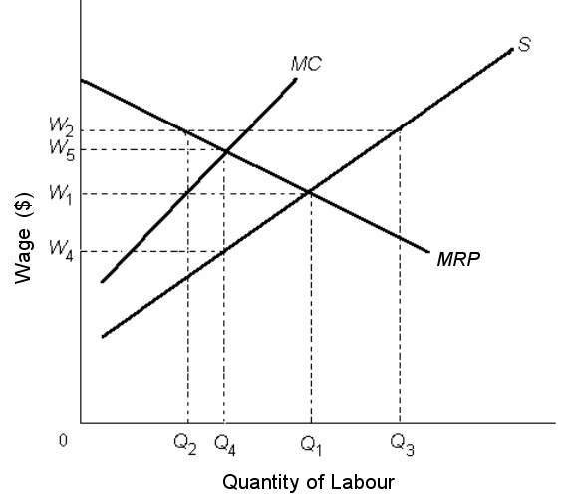
FIGURE 14-2

51) Refer to Figure 14-2. Suppose the labour market is perfectly competitive. If a minimum wage of W5 were then established, the predicted effect would be which one of the following?
A) Q2 workers would be employed and unemployment would equal Q2Q3.
B) Employment would fall by the amount Q1Q4.
C) Employment would remain the same as in a competitive market.
D) Q3 workers would now be employed.
E) Q4 workers would be employed and there would be no unemployment.
Answer: B
Diff: 2
Topic: 14.1c. wage differentials in non-competitive markets
Skill: Applied
Learning Obj.: 14-2 Describe the possible effects of legislated minimum wages.
User1: Graph
User2: Qualitative

52) Refer to Figure 14-2. If the labour market were in a monopsonistic equilibrium, the predicted wage and number of workers employed would be
A) W4 and Q4.
B) W5 and Q4.
C) W2 and Q1.
D) W1 and Q2.
E) W1 and Q3.
Answer: A
Diff: 2
Topic: 14.1c. wage differentials in non-competitive markets
Skill: Applied
Learning Obj.: 14-2 Describe the possible effects of legislated minimum wages.
User1: Graph
User2: Qualitative
53) Refer to Figure 14-2. Suppose the labour market is perfectly competitive. If a minimum wage of W4 is then established, the predicted change in the wage is
A) an increase in the wage paid.
B) a decrease in the wage paid.
C) no change in the wage paid.
D) a decrease equal to W1 - W4.
E) an increase equal to W1 - W4.
Answer: C
Diff: 2
Topic: 14.1c. wage differentials in non-competitive markets
Skill: Applied
Learning Obj.: 14-2 Describe the possible effects of legislated minimum wages.
User1: Graph
User2: Qualitative

54) Refer to Figure 14-2. Suppose the labour market is initially in a monopsonistic equilibrium. If a strong union is then formed and establishes a minimum wage of W1,
A) employment will decrease to Q2.
B) the wage rate and employment will both increase to their competitive levels.
C) the wage rate will increase but employment will decrease.
D) there will be an effect on either wages or employment but not both.
E) the wage rate will decrease but employment will increase.
Answer: B
Diff: 3
Topic: 14.1c. wage differentials in non-competitive markets
Skill: Applied
Learning Obj.: 14-2 Describe the possible effects of legislated minimum wages.
User1: Graph
User2: Qualitative

55) Refer to Figure 14-2. In a perfectly competitive labour market, the equilibrium wage rate and the quantity of labour employed would be
A) W4 and Q4.
B) W2 and Q2.
C) W5 and Q5.
D) W1 and Q1.
E) W5 and Q4.
Answer: D
Diff: 1
Topic: 14.1c. wage differentials in non-competitive markets
Skill: Applied
Learning Obj.: 14-2 Describe the possible effects of legislated minimum wages.
User1: Graph
User2: Qualitative
56) Refer to Figure 14-2. Suppose the labour market is in a monopsonistic equilibrium. If a minimum wage is then imposed at W5, the effect would be to
A) increase employment only.
B) waste policy effort, as there would be no effect whatsoever in the labour market.
C) increase wages and maintain employment but create a pool of unemployed workers.
D) increase wages and create a shortage of workers.
E) decrease wages but employment would remain the same.
Answer: C
Diff: 3
Topic: 14.1c. wage differentials in non-competitive markets
Skill: Applied
Learning Obj.: 14-2 Describe the possible effects of legislated minimum wages.
User1: Graph
User2: Qualitative

The three diagrams below show the supply and demand for teenage babysitters in one local area. The initial supply curve is S0 in all cases.

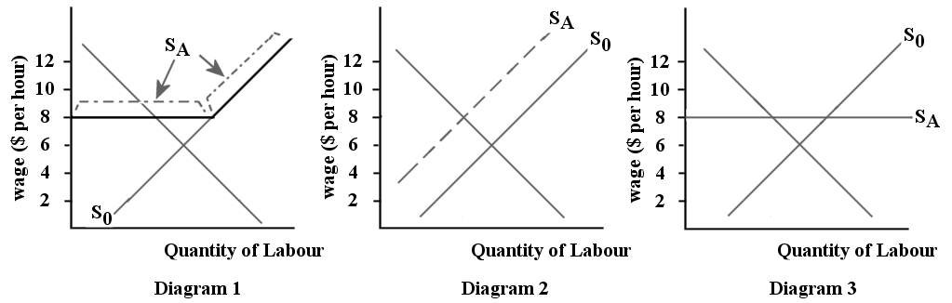

FIGURE 14-3

57) Refer to Figure 14-3. Suppose all of the teenage babysitters in one local area form an association and set a minimum age of 16 for working as a babysitter. Which diagram illustrates the new supply curve (SA) for babysitters?
A) diagram 1
B) diagram 2
C) diagram 3
D) none of the diagrams
E) any of the diagrams
Answer: B
Diff: 2
Topic: 14.1c. wage differentials in non-competitive markets
Skill: Applied
Learning Obj.: 14-2 Describe the possible effects of legislated minimum wages.
User1: Graph
User2: Qualitative
58) Refer to Figure 14-3. Suppose all of the teenage babysitters in one local area form an association and set a minimum acceptable wage of $8 per hour. Which diagram illustrates the new supply curve (SA) for babysitters?
A) diagram 1
B) diagram 2
C) diagram 3
D) none of the diagrams
E) any of the diagrams
Answer: A
Diff: 2
Topic: 14.1c. wage differentials in non-competitive markets
Skill: Applied
Learning Obj.: 14-2 Describe the possible effects of legislated minimum wages.
User1: Graph
User2: Qualitative

59) Suppose that the professional association of dentists reduces entry into their profession by lengthening the required training program. The likely effect is that
A) the supply curve of dentists will shift to the left.
B) the supply curve of dentists will shift to the right.
C) both the demand and supply curves for dentists will shift to the left.
D) the demand curve for dentists will shift to the right.
E) there will be an increase in the quantity of dentists supplied.
Answer: A
Diff: 1
Topic: 14.1c. wage differentials in non-competitive markets
Skill: Applied
Learning Obj.: 14-2 Describe the possible effects of legislated minimum wages.
User2: Qualitative

The diagram below shows the supply and demand for labour in a hypothetical town in northern British Columbia, with only one employer, a logging company.

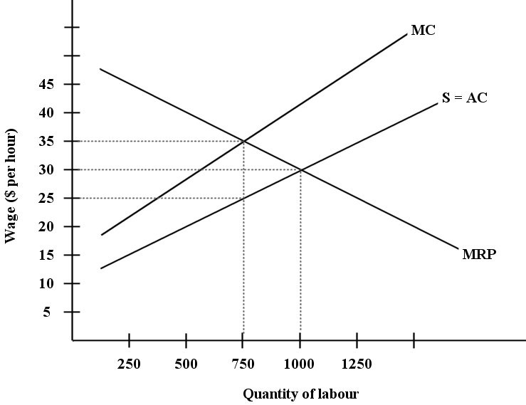
FIGURE 14-4

60) Refer to Figure 14-4. The wage paid by this monopsonistic firm will be ________ and employment will be ________.
A) below $25 per hour; below 750 units of labour
B) between $25 and $35 per hour; between 750 and 1000 units of labour
C) $30 per hour; 1000 units of labour
D) $25 per hour; 750 units of labour
E) $35 per hour; 750 units of labour
Answer: D
Diff: 2
Topic: 14.1c. wage differentials in non-competitive markets
Skill: Applied
Learning Obj.: 14-2 Describe the possible effects of legislated minimum wages.
User1: Graph
User2: Quantitative

61) Refer to Figure 14-4. Compared to the outcome in a competitive labour market, the wage and employment outcome in this town's monopsonistic labour market are as follows:
A) wages are lower by $5 per hour and employment is lower by 250 units of labour.
B) wages and employment are both the same as the competitive outcome.
C) wages are higher by $10 per hour and employment is lower by 250 units of labour.
D) wages are lower by $10 per hour and employment is the same as the competitive outcome.
E) wages are the same as the competitive outcome and employment is higher by 250 units of labour.
Answer: A
Diff: 3
Topic: 14.1c. wage differentials in non-competitive markets
Skill: Applied
Learning Obj.: 14-2 Describe the possible effects of legislated minimum wages.
User1: Graph
User2: Quantitative

62) Refer to Figure 14-4. Suppose this labour market is in a monopsonistic equilibrium. Then, suppose the workers form a union and negotiate a higher wage with the firm. In this case the wage will be ________ and the employment will be ________.
A) above $35 per hour; less than 750 units of labour
B) between $25 and $35 per hour; between 750 and 1000 units of labour
C) above $25 per hour; above or below 750 units of labour, depending on the negotiated wage
D) $30 per hour; 1000 units of labour
E) $35 per hour; 750 units of labour
Answer: C
Diff: 3
Topic: 14.1c. wage differentials in non-competitive markets
Skill: Applied
Learning Obj.: 14-2 Describe the possible effects of legislated minimum wages.
User1: Graph
User2: Quantitative
63) Refer to Figure 14-4. Suppose the workers in this town form a union to negotiate the wage rate with the firm. Economists refer to this situation as
A) a monopoly.
B) a unionized monopoly.
C) a competitive labour market.
D) a monopolistic labour market.
E) a bilateral monopoly.
Answer: E
Diff: 2
Topic: 14.1c. wage differentials in non-competitive markets
Skill: Applied
Learning Obj.: 14-2 Describe the possible effects of legislated minimum wages.
User1: Graph
User2: Qualitative

64) Refer to Figure 14-4. Suppose this labour market is in a monopsonistic equilibrium. Then, suppose the provincial government of British Columbia imposes a minimum wage for employees in this industry of $30 per hour. What will be the effects on wages and employment?
A) wages will fall by $5 per hour and employment will increase by 250 units of labour
B) wages will not change and employment will increase by 250 units of labour
C) wages will rise by $5 per hour and employment will increase by 250 units of labour
D) wages will not change and employment will change by between 0 and 250 units of labour
E) wages will not change and employment will not change
Answer: C
Diff: 3
Topic: 14.1c. wage differentials in non-competitive markets
Skill: Applied
Learning Obj.: 14-2 Describe the possible effects of legislated minimum wages.
User1: Graph
User2: Qualitative

65) Refer to Figure 14-4. Suppose this labour market is in a monopsonistic equilibrium. Then, suppose the provincial government of British Columbia imposes a minimum wage for employees in this industry of $38 per hour. What will be the effects on wages and employment?
A) wages will rise by $8 per hour and employment will fall below 750 units of labour
B) wages will rise by $3 per hour and employment will fall by 125 units of labour
C) wages will rise by $8 per hour and employment will remain unchanged
D) wages will rise by $13 per hour and employment will fall below 750 units of labour
E) wages will rise by $8 per hour and employment will fall by between 0 and 250 units of labour
Answer: D
Diff: 3
Topic: 14.1c. wage differentials in non-competitive markets
Skill: Applied
Learning Obj.: 14-2 Describe the possible effects of legislated minimum wages.
User1: Graph
User2: Qualitative
66) Suppose there is a competitive market for retail workers at a large shopping mall that is large enough to constitute its own labour market. The labour demand curve is QD = 1000 - 20(w). The labour supply curve is QS = 400 + 40(w). What is the equilibrium level of employment?
A) 20
B) 40
C) 400
D) 800
E) 1000
Answer: D
Diff: 3
Topic: 14.1c. wage differentials in non-competitive markets
Skill: Applied
Learning Obj.: 14-2 Describe the possible effects of legislated minimum wages.
User2: Quantitative

67) Suppose there is a competitive market for retail workers at a large shopping mall that is large enough to constitute its own labour market. The labour demand curve is QD = 1000 - 20(w). The labour supply curve is QS = 400 + 40(w). Suppose that a union now successfully organizes the workers at this mall and obtains a wage rate of $11 (but does not affect the demand curve). The number of workers employed after unionization is
A) 400.
B) 780.
C) 880.
D) 1000.
E) Not determinable from the information provided.
Answer: B
Diff: 3
Topic: 14.1c. wage differentials in non-competitive markets
Skill: Applied
Learning Obj.: 14-2 Describe the possible effects of legislated minimum wages.
User2: Quantitative

68) Suppose there is a competitive market for retail workers at a large shopping mall that is large enough to constitute its own labour market. The labour demand curve is QD = 1000 - 20(w). The labour supply curve is QS = 400 + 40(w). Suppose that a union now successfully organizes the workers at this mall and obtains a wage rate of $11 (but does not affect the demand curve). The number of workers who wish to work at the new wage is
A) 400.
B) 440.
C) 780.
D) 840.
E) 1000.
Answer: D
Diff: 3
Topic: 14.1c. wage differentials in non-competitive markets
Skill: Applied
Learning Obj.: 14-2 Describe the possible effects of legislated minimum wages.
User2: Quantitative
69) Suppose there is a competitive market for retail workers at a large shopping mall that is large enough to constitute its own labour market. The labour demand curve is QD = 1000 - 20(w). The labour supply curve is QS = 400 + 40(w). Suppose that a union now successfully organizes the workers at this mall and obtains a wage rate of $11 (but does not affect the demand curve). One result is
A) an increase in employment of 20 workers.
B) an increase in employment of 40 workers.
C) a decrease in employment of 20 workers.
D) a decrease in employment of 40 workers.
E) a decrease in employment of 60 workers.
Answer: C
Diff: 3
Topic: 14.1c. wage differentials in non-competitive markets
Skill: Applied
Learning Obj.: 14-2 Describe the possible effects of legislated minimum wages.
User2: Quantitative

70) Suppose there is a competitive market for retail workers at a large shopping mall that is large enough to constitute its own labour market. The labour demand curve is QD = 1000 - 20(w). The labour supply curve is QS = 400 + 40(w). Suppose that a union now successfully organizes the workers at this mall and obtains a wage rate of $11 (but does not affect the demand curve). The number of unemployed workers in this mall labour market becomes
A) 20.
B) 40.
C) 60.
D) 80.
E) 100.
Answer: C
Diff: 3
Topic: 14.1c. wage differentials in non-competitive markets
Skill: Applied
Learning Obj.: 14-2 Describe the possible effects of legislated minimum wages.
User2: Quantitative

71) Suppose there is a competitive market for retail workers at a large shopping mall that is large enough to constitute its own labour market. The labour demand curve is QD = 1000 - 20(w). The labour supply curve is QS = 400 + 40(w). Suppose that a union now successfully organizes the workers at this mall and obtains a wage rate of $13 (but does not affect the position of the demand curve). One result is
A) an increase in employment of 20 workers.
B) an increase in employment of 60 workers.
C) a decrease in employment of 100 workers.
D) a decrease in employment of 140 workers.
E) a decrease in employment of 60 workers.
Answer: E
Diff: 3
Topic: 14.1c. wage differentials in non-competitive markets
Skill: Applied
Learning Obj.: 14-2 Describe the possible effects of legislated minimum wages.
User2: Quantitative
72) A legislated minimum wage is said to be binding when
A) it is below an industry's free-market equilibrium wage.
B) an industry is poorly organized and composed largely of unskilled labour.
C) it raises wage rates in an industry above the free-market equilibrium level.
D) it decreases the turnover rate among employees.
E) it is enforced by legal authorities.
Answer: C
Diff: 1
Topic: 14.1d. legislated minimum wages
Skill: Recall
Learning Obj.: 14-2 Describe the possible effects of legislated minimum wages.
User2: Qualitative

73) A legislated minimum wage is comparable to
A) bilateral monopoly.
B) a black-market price.
C) a rent control.
D) a price ceiling.
E) a price floor.
Answer: E
Diff: 1
Topic: 14.1d. legislated minimum wages
Skill: Recall
Learning Obj.: 14-2 Describe the possible effects of legislated minimum wages.
User2: Qualitative

74) If a minimum wage is set above the free-market equilibrium wage in a competitive labour market, the labour market will experience an increase in wages and
A) employment will increase.
B) employment will decrease.
C) there will be no unemployment.
D) employment will remain the same.
E) there is an unpredictable effect on employment.
Answer: B
Diff: 1
Topic: 14.1d. legislated minimum wages
Skill: Recall
Learning Obj.: 14-2 Describe the possible effects of legislated minimum wages.
User2: Qualitative
75) Which of the following statements about a legislated minimum wage is true?
A) In a competitive labour market, (if effective) it may increase wages and will increase employment.
B) In a monopsonistic labour market, (if effective) it may increase wage rates but it must decrease employment.
C) In a monopsonistic labour market, if set equal to the competitive wage, will increase wages and employment.
D) It will have the same wage and employment effects in competitive and monopsonistic labour markets.
E) It will have no effect if the market is monopsonistic.
Answer: C
Diff: 2
Topic: 14.1d. legislated minimum wages
Skill: Recall
Learning Obj.: 14-2 Describe the possible effects of legislated minimum wages.
User2: Qualitative
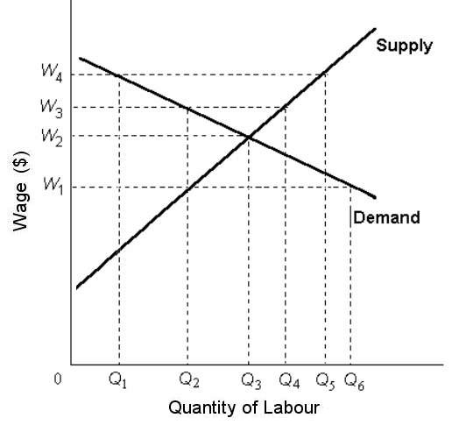
FIGURE 14-5

76) Refer to Figure 14-5. If this labour market were perfectly competitive, the predicted wage and employment level would be
A) W1 and Q2.
B) W2 and Q3.
C) W3 and Q2.
D) W3 and Q4.
E) W4 and Q5.
Answer: B
Diff: 1
Topic: 14.1d. legislated minimum wages
Skill: Applied
Learning Obj.: 14-2 Describe the possible effects of legislated minimum wages.
User1: Graph
User2: Qualitative

77) Refer to Figure 14-5. Suppose this labour market is perfectly competitive. If a minimum wage of W1 is then imposed, the quantity of labour hired would be
A) Q1.
B) Q2.
C) Q3.
D) Q4.
E) Q5.
Answer: C
Diff: 1
Topic: 14.1d. legislated minimum wages
Skill: Applied
Learning Obj.: 14-2 Describe the possible effects of legislated minimum wages.
User1: Graph
User2: Qualitative
78) Refer to Figure 14-5. Suppose this labour market is competitive. If a minimum wage of W3 is then imposed, the quantity of labour hired would be
A) Q1.
B) Q2.
C) Q3.
D) Q4.
E) Q5.
Answer: B
Diff: 1
Topic: 14.1d. legislated minimum wages
Skill: Applied
Learning Obj.: 14-2 Describe the possible effects of legislated minimum wages.
User1: Graph
User2: Qualitative

79) Refer to Figure 14-5. Suppose this labour market is competitive. If a minimum wage of W4 is then imposed, the quantity of labour supplied would be
A) Q1.
B) Q2.
C) Q3.
D) Q4.
E) Q5.
Answer: E
Diff: 2
Topic: 14.1d. legislated minimum wages
Skill: Applied
Learning Obj.: 14-2 Describe the possible effects of legislated minimum wages.
User1: Graph
User2: Qualitative

80) Refer to Figure 14-5. Suppose this labour market is competitive. If a minimum wage of W4 is then imposed, the number of unemployed workers would be
A) 0Q1.
B) Q5 - Q1.
C) Q3 - Q1.
D) 0Q3.
E) 0Q5.
Answer: B
Diff: 2
Topic: 14.1d. legislated minimum wages
Skill: Applied
Learning Obj.: 14-2 Describe the possible effects of legislated minimum wages.
User1: Graph
User2: Qualitative
81) Refer to Figure 14-5. Suppose the labour market is competitive. If a minimum wage of W3 is then imposed, the number of unemployed workers would be
A) 0Q2.
B) Q3 - Q1.
C) Q3 - Q2.
D) Q4 - Q2.
E) 0Q4.
Answer: D
Diff: 2
Topic: 14.1d. legislated minimum wages
Skill: Applied
Learning Obj.: 14-2 Describe the possible effects of legislated minimum wages.
User1: Graph
User2: Qualitative

82) Refer to Figure 14-5. If this labour market is perfectly competitive, an increase in the legislated minimum wage from W2 to W3 would
A) have no effect on employment.
B) create unemployment where there previously was none.
C) increase employment from what would have initially occurred.
D) create unemployment in other minimum wage sectors.
E) increase employment in this industry but decrease it in other industries.
Answer: B
Diff: 3
Topic: 14.1d. legislated minimum wages
Skill: Applied
Learning Obj.: 14-2 Describe the possible effects of legislated minimum wages.
User1: Graph
User2: Qualitative

83) Which of the following statements about minimum-wage laws is most accurate?
A) All Canadian provinces have the same minimum wage.
B) There is some evidence that minimum-wage laws cause additional unemployment, particularly among youths.
C) Minimum-wage laws only affect the income of the higher-skilled, lowest-wage workers.
D) Minimum-wage laws are unfair.
E) There is some evidence that minimum-wage laws create a lot of jobs, particularly among youths.
Answer: B
Diff: 1
Topic: 14.1d. legislated minimum wages
Skill: Recall
Learning Obj.: 14-2 Describe the possible effects of legislated minimum wages.
User2: Qualitative
84) Canadian studies on the effects of minimum-wage laws
A) suggest that they have no effect whatsoever on employment.
B) support the evidence from the United States that these laws increase wages and employment.
C) support the theoretical predictions that minimum-wage laws increase employment.
D) find that employment increases with increases in minimum wages, thus supporting the argument that labour markets are monopsonistic.
E) find that they decrease the level of employment, particularly for low-skilled workers.
Answer: E
Diff: 2
Topic: 14.1d. legislated minimum wages
Skill: Recall
Learning Obj.: 14-2 Describe the possible effects of legislated minimum wages.
User2: Qualitative

The three diagrams below show the supply and demand for teenage babysitters in one local area. The initial supply curve is S0 in all cases.

FIGURE 14-3

85) Refer to Figure 14-3. Suppose the teenage babysitters in one local area are earning an equilibrium wage of $6 per hour. Now suppose that the local government imposes a minimum wage of $8 per hour for babysitters. Which diagram illustrates the new supply curve (SA) for babysitters?
A) diagram 1
B) diagram 2
C) diagram 3
D) none of the diagrams
E) any of the diagrams
Answer: A
Diff: 2
Topic: 14.1d. legislated minimum wages
Skill: Applied
Learning Obj.: 14-2 Describe the possible effects of legislated minimum wages.
User1: Graph
User2: Qualitative
86) Refer to Figure 14-3. Suppose the teenage babysitters in one local area are earning an equilibrium wage of $6 per hour. Now suppose the local government reduces the minimum age for working as a babysitter from 14 to 12 years of age. Which diagram illustrates the new supply curve (SA) for babysitters?
A) diagram 1
B) diagram 2
C) diagram 3
D) none of the diagrams
E) any of the diagrams
Answer: D
Diff: 2
Topic: 14.1d. legislated minimum wages
Skill: Applied
Learning Obj.: 14-2 Describe the possible effects of legislated minimum wages.
User1: Graph
User2: Qualitative

The table below shows the labour demand and labour supply schedules in a competitive labour market.

Wage Rate  ($/hour) | Quantity Demanded  of Labour  (hours/month) | Quantity Supplied  of Labour (hours/month)
10 | 1300 | 500
12 | 1000 | 1000
14 | 800 | 1300
15 | 400 | 1500
17 | 200 | 1800

TABLE 14-1

87) Refer to Table 14-1. In a competitive labour market, a legislated minimum wage imposed at $10 per hour would
A) have no effect on the competitive equilibrium level of employment.
B) lead to unemployment of 500 hours/month.
C) lead to over-employment of 500 hours/month.
D) lead to an equilibrium wage higher than the competitive wage.
E) lead to an employment level lower than the competitive level.
Answer: A
Diff: 2
Topic: 14.1d. legislated minimum wages
Skill: Applied
Learning Obj.: 14-2 Describe the possible effects of legislated minimum wages.
User1: Table
User2: Qualitative
88) Refer to Table 14-1. In a competitive labour market, a legislated minimum wage imposed at $14 per hour would
A) have no effect on the competitive equilibrium level of employment.
B) have no effect on the competitive equilibrium wage.
C) lead to unemployment of 500 hours/month.
D) lead to unemployment of 300 hours/month.
E) lead to an equilibrium wage lower than the competitive wage.
Answer: C
Diff: 2
Topic: 14.1d. legislated minimum wages
Skill: Applied
Learning Obj.: 14-2 Describe the possible effects of legislated minimum wages.
User1: Table
User2: Quantitative

14.2 Labour Unions

1) In general, in collective bargaining between a labour union and a firm, the
A) union sets the wage and the employer decides how much labour will be hired.
B) employer sets the wages and the union decides how many workers will be hired.
C) wage is negotiated, whereas the firm is generally free to choose the level of employment.
D) wage and the number of workers to be hired is negotiated.
E) only the level of employment is negotiated.
Answer: C
Diff: 1
Topic: 14.2. labour unions
Skill: Recall
Learning Obj.: 14-3 Discuss the tradeoff that unions usually face between wages and employment.
User2: Qualitative
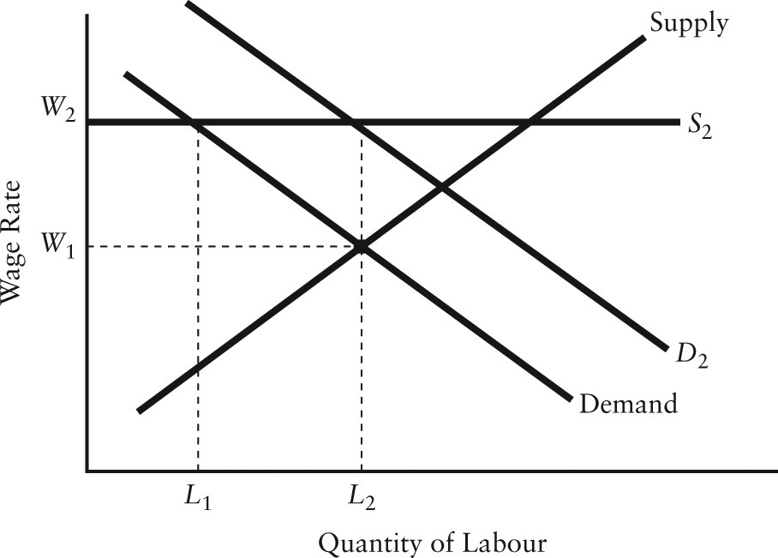
FIGURE 14-6

2) Refer to Figure 14-6. The market begins in equilibrium with the curves labelled Demand and Supply. If a labour union negotiates the wage to W2, the difference between this wage and the competitive equilibrium wage is called
A) the industry's wage premium.
B) the union wage premium.
C) a temporary wage differential.
D) a discrimination differential.
E) a legislated wage differential.
Answer: B
Diff: 1
Topic: 14.2. labour unions
Skill: Recall
Learning Obj.: 14-3 Discuss the tradeoff that unions usually face between wages and employment.
User1: Graph
User2: Qualitative

3) Refer to Figure 14-6. The market begins in equilibrium with the curves labelled Demand and Supply. If a labour union negotiates the wage to W2 in an otherwise competitive labour market,
A) the supply of labour will stay the same.
B) employers will hire L2 quantity of labour.
C) the demand for labour will shift to D2.
D) employers will hire L1 quantity of labour.
E) equilibrium will occur at W1 and L2.
Answer: D
Diff: 1
Topic: 14.2. labour unions
Skill: Recall
Learning Obj.: 14-3 Discuss the tradeoff that unions usually face between wages and employment.
User1: Graph
User2: Qualitative
4) Economists observe clear evidence of a union wage premium but do not observe the clear union effect on employment levels predicted from theory. One explanation for this is
A) that the labour supply curve shifts to the right in the collective bargaining process, thereby eliminating any employment effect.
B) that the labour supply curve, in the presence of a union, is very inelastic, which implies only a very small effect on employment.
C) that union-based advertising for the product increases demand for the product, shifts the demand curve to the right and eliminates any employment effect.
D) the union's ability, through the collective bargaining process, to pressure firms to hire more workers than they otherwise would at the union wage.
E) both C and D are correct.
Answer: E
Diff: 2
Topic: 14.2. labour unions
Skill: Recall
Learning Obj.: 14-3 Discuss the tradeoff that unions usually face between wages and employment.
User2: Qualitative

5) If a wage-setting union enters a monopsonistic labour market, the union can cause
A) wages to rise to what would have been the competitive level but no higher.
B) wages to rise above the level set by the monopsonist, but only if it allows employment to fall below the level set by the monopsonist.
C) both wages and employment to rise over the monopsonistic level.
D) wages or employment to rise above the level set by the monopsonist, but not both.
E) the level of non-wage benefits to rise but cannot affect either wages or employment.
Answer: C
Diff: 2
Topic: 14.2. labour unions
Skill: Applied
Learning Obj.: 14-3 Discuss the tradeoff that unions usually face between wages and employment.
User2: Qualitative

6) If a union succeeds in shifting the labour supply curve to the left, it can achieve wages above the
A) competitive level and all workers will gain.
B) equilibrium level and an increase in employment.
C) equilibrium level without affecting employment.
D) competitive level but will reduce the level of employment.
E) competitive level without a pool of unemployed workers seeking to work at the higher wage.
Answer: D
Diff: 2
Topic: 14.2. labour unions
Skill: Applied
Learning Obj.: 14-3 Discuss the tradeoff that unions usually face between wages and employment.
User2: Qualitative
7) The fundamental dilemma facing labour unions is
A) job security versus worker safety.
B) wage increases versus employment growth.
C) wage increases versus publicly provided pensions.
D) members' roles as workers versus their roles as consumers.
E) "featherbedding" versus the union-wage premium.
Answer: B
Diff: 2
Topic: 14.2. labour unions
Skill: Recall
Learning Obj.: 14-3 Discuss the tradeoff that unions usually face between wages and employment.
User2: Qualitative

8) Unions currently represent ________ employed workers in Canada.
A) all of the
B) half of the
C) more than 50% of
D) approximately 30% of
E) less than 10% of
Answer: D
Diff: 1
Topic: 14.2. labour unions
Skill: Recall
Learning Obj.: 14-3 Discuss the tradeoff that unions usually face between wages and employment.
User2: Qualitative

9) Unions currently represent ________ government employees in Canada.
A) all of the
B) approximately half of the
C) over 70% of
D) less than 30% of
E) less than 10% of
Answer: C
Diff: 1
Topic: 14.2. labour unions
Skill: Recall
Learning Obj.: 14-3 Discuss the tradeoff that unions usually face between wages and employment.
User2: Qualitative

10) The average union wage premium in Canada is
A) less than 10%.
B) between 10 and 15%.
C) between 15 and 30%.
D) between 30 and 50%.
E) more than 50%.
Answer: B
Diff: 1
Topic: 14.2. labour unions
Skill: Recall
Learning Obj.: 14-3 Discuss the tradeoff that unions usually face between wages and employment.
User2: Qualitative
11) The union wage premium refers to the
A) portion of a union wage attributable to fees payable to the union.
B) trade-off the union faces between the level of the wage and the size of the union.
C) higher wage attributable only to the union status of the job.
D) wage that a union is able to set unilaterally.
E) wage that an employer is able to set unilaterally.
Answer: C
Diff: 1
Topic: 14.2. labour unions
Skill: Recall
Learning Obj.: 14-3 Discuss the tradeoff that unions usually face between wages and employment.
User2: Qualitative

12) The purpose of a labour union is to
A) maintain a minimum level of employment.
B) exploit its labour-market power in the same way a monopolist exploits its market power in product markets.
C) exploit its labour-market power in the same way a monopolist exploits its market power in labour markets.
D) increase employment in its industry.
E) decrease employment in its industry.
Answer: B
Diff: 2
Topic: 14.2. labour unions
Skill: Recall
Learning Obj.: 14-3 Discuss the tradeoff that unions usually face between wages and employment.
User2: Qualitative

13) One of the most unionized industries in Canada is
A) agriculture.
B) finance and insurance.
C) real estate.
D) education.
E) non-governmental administrative services.
Answer: D
Diff: 1
Topic: 14.2. labour unions
Skill: Recall
Learning Obj.: 14-3 Discuss the tradeoff that unions usually face between wages and employment.
User2: Qualitative
14) An important unanswered question about the role of unions in developed economies is whether the presence of unions affects long-run productivity. There is some evidence to suggest that the presence of a union
A) increases the human capital of unionized workers, which leads to increased long-run productivity for the firm.
B) reduces the demand for labour and therefore the demand for physical capital.
C) decreases the human capital of unionized workers, and therefore reduces long-run productivity.
D) reduces the level of employment (because of the union-wage premium) and thus raises the marginal product of labour.
E) reduces the expected profitability of installed capital and therefore leads to reduced capital investment by firms.
Answer: E
Diff: 3
Topic: 14.2. labour unions
Skill: Recall
Learning Obj.: 14-3 Discuss the tradeoff that unions usually face between wages and employment.
User2: Qualitative

14.3 Income Inequality

1) When studying income distribution, the Classical economists were primarily concerned with the distribution of income among
A) workers and the government.
B) workers and capitalists.
C) the government and capitalists.
D) workers and landowners.
E) workers, capitalists, and landowners.
Answer: E
Diff: 1
Topic: 14.3a. income distribution
Skill: Recall
Learning Obj.: 13-1 Determine a profit‐maximizing firm's demand for a factor of production.
User2: Qualitative

2) The "functional distribution of income" refers to the distribution of income
A) among the various social classes.
B) among the major factors of production.
C) among the industrial nations.
D) between the government and the factors of production.
E) between the various economic sectors of a country.
Answer: B
Diff: 1
Topic: 14.3a. income distribution
Skill: Recall
Learning Obj.: 13-1 Determine a profit‐maximizing firm's demand for a factor of production.
User2: Qualitative
3) The "size distribution of income" refers to the distribution of income
A) among different households with reference to the source of the income.
B) between capitalists and workers.
C) between capitalists and landowners.
D) among different individuals without reference to the source of the income.
E) to a particular factor of production in different time periods.
Answer: D
Diff: 1
Topic: 14.3a. income distribution
Skill: Recall
Learning Obj.: 13-1 Determine a profit‐maximizing firm's demand for a factor of production.
User2: Qualitative

4) A Lorenz curve shows the
A) degree of inequality across households in the distribution of income.
B) ratio of workers' income to capitalists' income.
C) level of a country's income relative to its productive capacity.
D) level of a country's income relative to its foreign trade.
E) functional distribution of income.
Answer: A
Diff: 1
Topic: 14.3a. income distribution
Skill: Recall
Learning Obj.: 13-1 Determine a profit‐maximizing firm's demand for a factor of production.
User2: Qualitative

5) In a Lorenz curve diagram, the size of the area between the Lorenz curve and the diagonal line represents
A) the degree of inequality in the distribution of income.
B) the percentage of income received by the bottom 20% of families.
C) the dollar incomes of the bottom 40% of families.
D) the percentage of income received by the top 5% of families.
E) complete income equality.
Answer: A
Diff: 2
Topic: 14.3a. income distribution
Skill: Recall
Learning Obj.: 13-1 Determine a profit‐maximizing firm's demand for a factor of production.
User2: Qualitative

6) The diagonal line on a Lorenz curve diagram represents
A) the degree of inequality in the distribution of income.
B) the percentage of income received by the bottom 50% of families.
C) the dollar incomes of the bottom 50% of families.
D) the percentage of income received by the top 50% of families.
E) where the Lorenz curve would be if there were complete income equality.
Answer: E
Diff: 2
Topic: 14.3a. income distribution
Skill: Recall
Learning Obj.: 13-1 Determine a profit‐maximizing firm's demand for a factor of production.
User2: Qualitative
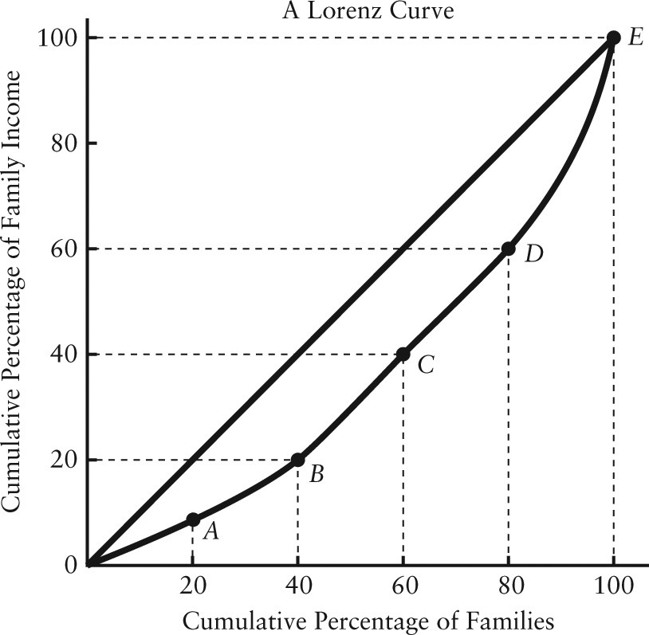

FIGURE 14-7

7) Refer to Figure 14-7. The diagonal line in the diagram
A) illustrates the functional distribution of income.
B) shows where the Lorenz curve would be if there were complete income equality.
C) shows the actual distribution of income.
D) has no real purpose.
E) shows the distribution of income over time.
Answer: B
Diff: 1
Topic: 14.3a. income distribution
Skill: Recall
Learning Obj.: 13-1 Determine a profit‐maximizing firm's demand for a factor of production.
User1: Graph
User2: Qualitative
8) Refer to Figure 14-7. Which point shows that 100% of families earn 100% of the income?
A) A
B) B
C) C
D) D
E) E
Answer: E
Diff: 1
Topic: 14.3a. income distribution
Skill: Applied
Learning Obj.: 13-1 Determine a profit‐maximizing firm's demand for a factor of production.
User1: Graph
User2: Qualitative

9) Refer to Figure 14-7. Which point shows that 20% of families earn almost 40% of total income?
A) A
B) B
C) C
D) D
E) E
Answer: D
Diff: 3
Topic: 14.3a. income distribution
Skill: Applied
Learning Obj.: 13-1 Determine a profit‐maximizing firm's demand for a factor of production.
User1: Graph
User2: Qualitative

10) Refer to Figure 14-7. Which point shows that the bottom 60% of families earn just under 40% of total income?
A) A
B) B
C) C
D) D
E) E
Answer: C
Diff: 1
Topic: 14.3a. income distribution
Skill: Applied
Learning Obj.: 13-1 Determine a profit‐maximizing firm's demand for a factor of production.
User1: Graph
User2: Qualitative
11) Refer to Figure 14-7. On the Lorenz curve shown in the diagram,
A) the poorest 20% of families earn almost 90% of total income.
B) perfect equality of income distribution occurs.
C) the richest 20% of families earn over 60% of total income.
D) the functional distribution of income is shown.
E) the richest 20% of families earn almost 40% of total income.
Answer: E
Diff: 2
Topic: 14.3a. income distribution
Skill: Applied
Learning Obj.: 13-1 Determine a profit‐maximizing firm's demand for a factor of production.
User1: Graph
User2: Qualitative

12) Suppose all Canadians earned equal incomes. In this case, Canada's Lorenz curve would be
A) coincident with the horizontal axis.
B) the diagonal line.
C) above the diagonal line.
D) below the diagonal line.
E) non-existent.
Answer: B
Diff: 2
Topic: 14.3a. income distribution
Skill: Applied
Learning Obj.: 13-1 Determine a profit‐maximizing firm's demand for a factor of production.
User2: Qualitative

13) Median family income (pre-tax) in Canada in 2012 was closest to
A) $45 000.
B) $52 000.
C) $65 000.
D) $82 000.
E) $95 000.
Answer: D
Diff: 1
Topic: 14.3a. income distribution
Skill: Recall
Learning Obj.: 13-1 Determine a profit‐maximizing firm's demand for a factor of production.
User2: Quantitative
14) A Lorenz curve showing the current distribution of pre-tax income in Canada is not an entirely accurate depiction of Canadian income distribution because
A) Statistics Canada does not actually collect data on Canadian household income.
B) Canada's tax-and-transfer system reduces income inequality, which causes the Lorenz curve to be flatter and closer to the diagonal than the pre-tax curve.
C) the data collected on Canadian income distribution does not allow for an accurate plotting of a Lorenz curve.
D) a Lorenz curve cannot depict the distribution of income after government transfer payments have been distributed to households.
E) a Lorenz curve cannot depict the distribution of after-tax income.
Answer: A
Diff: 2
Topic: 14.3a. income distribution
Skill: Applied
User2: Qualitative

15) If Canada's Lorenz curve began changing such that it bends further from the diagonal line and becomes more curved, this would be an indication that
A) data collection on Canadian household incomes is improving.
B) the distribution of income in Canada is becoming more unequal.
C) the distribution of income in Canada is becoming more equal.
D) average Canadian family income is rising.
E) average Canadian family income is falling.
Answer: B
Diff: 2
Topic: 14.3a. income distribution
Skill: Applied
User2: Qualitative

16) Much attention is being paid to the issue of rising income inequality. A serious aspect of this issue, especially in the United States and the United Kingdom , is that even though average per capita income has been growing,
A) a larger proportion of households fall below the poverty line.
B) high-income earners are paying much higher rates of income tax.
C) the vast majority of the economy's total income growth has accrued to the highest income earners.
D) low- and middle-class households are not earning enough income to pay income tax.
E) incomes in these countries are not growing as fast as in other OECD countries.
Answer: C
Diff: 2
Topic: 14.3b. income inequality
Skill: Recall
User2: Qualitative
17) Researchers are trying to identify the causes of rising income inequality in various economies. Important forces that are almost certainly contributing are:
1) globalization
2) rising rates of personal income tax
3) skill-biased technological change
A) 1 and 2 only
B) 2 and 3 only
C) 1 on
D) 2 only
E) 1 and 3 only
Answer: E
Diff: 1
Topic: 14.3b. income inequality
Skill: Recall
User2: Qualitative

